The Mental Clarity app is designed to help users improve mental space, by creating todo lists and engaging in meditations. There will be 5 pages:
- A home page
- A new to do list page
- A benefits of to do lists page
- A meditation page.
- A reflective journal page

The Home page will be a standard landing page with brief introduction and information about the website. The navbar will give a selection of 4 pages: home, todo lists, benefits, and meditation.

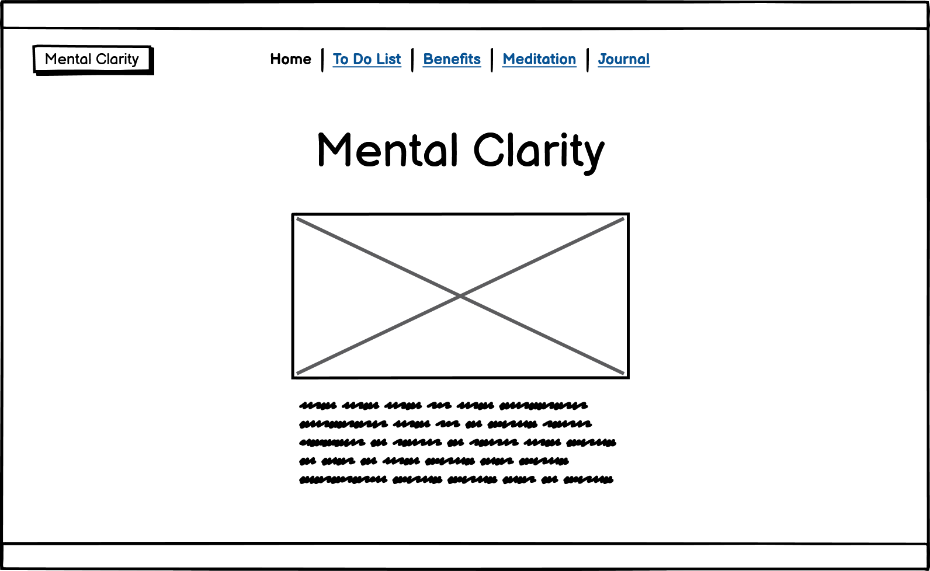

The To Do List page will be the New List page by default, but it will have a submenu that offers the user the option to view past lists. On the new todo list page, the user will be able to edit, delete, and add new tasks to the list. They will also be able to check off tasks that they have completed.
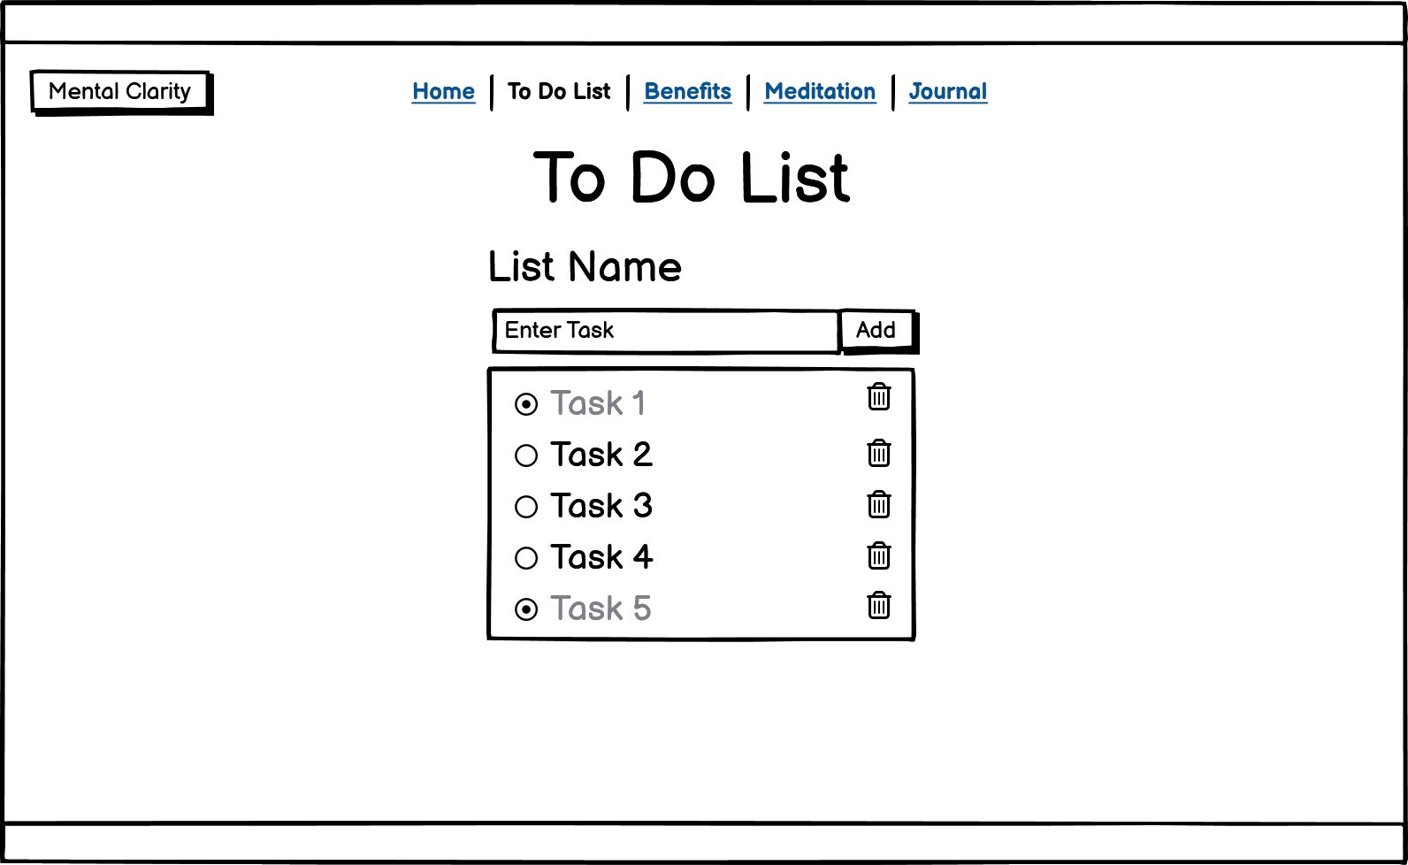

The Benefits page is dedicated to informing the user about to do lists and their benefits, particularly in relation to mental health.

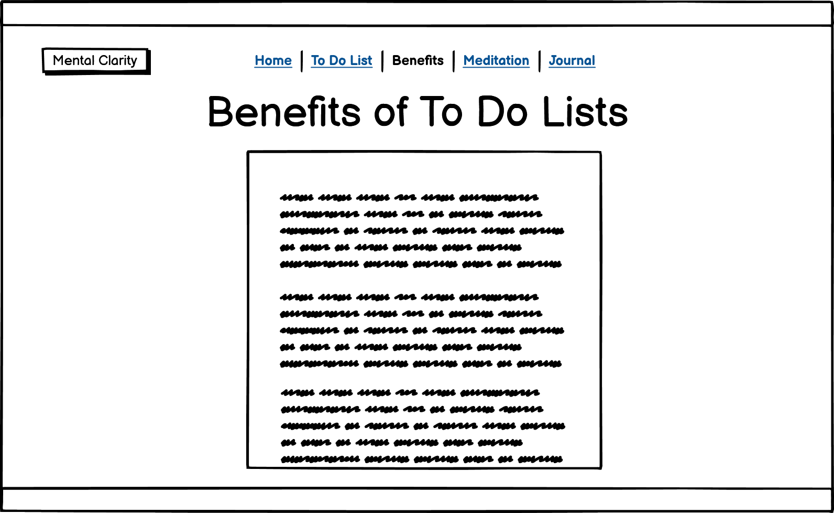

The Meditation page will offer users video meditations by utilising the HTML5 video feature. Each video will have a description of the meditation and its benefits.
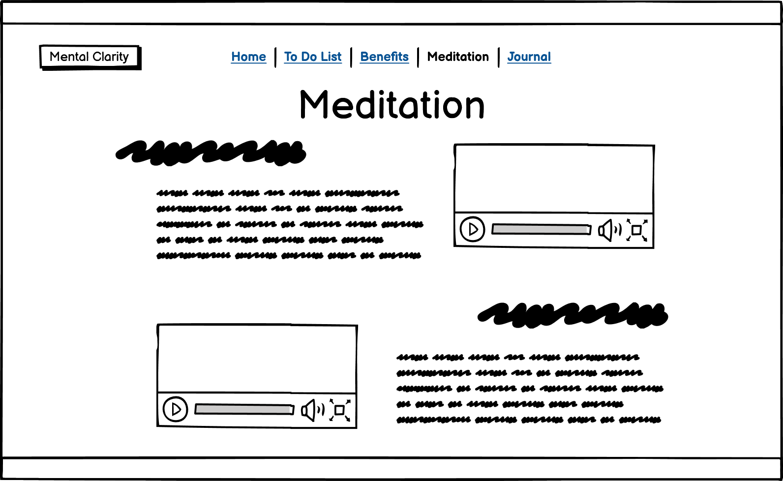

Finally, the journal page will allow users to reflect on how they are feeling and write it out into the online journal.